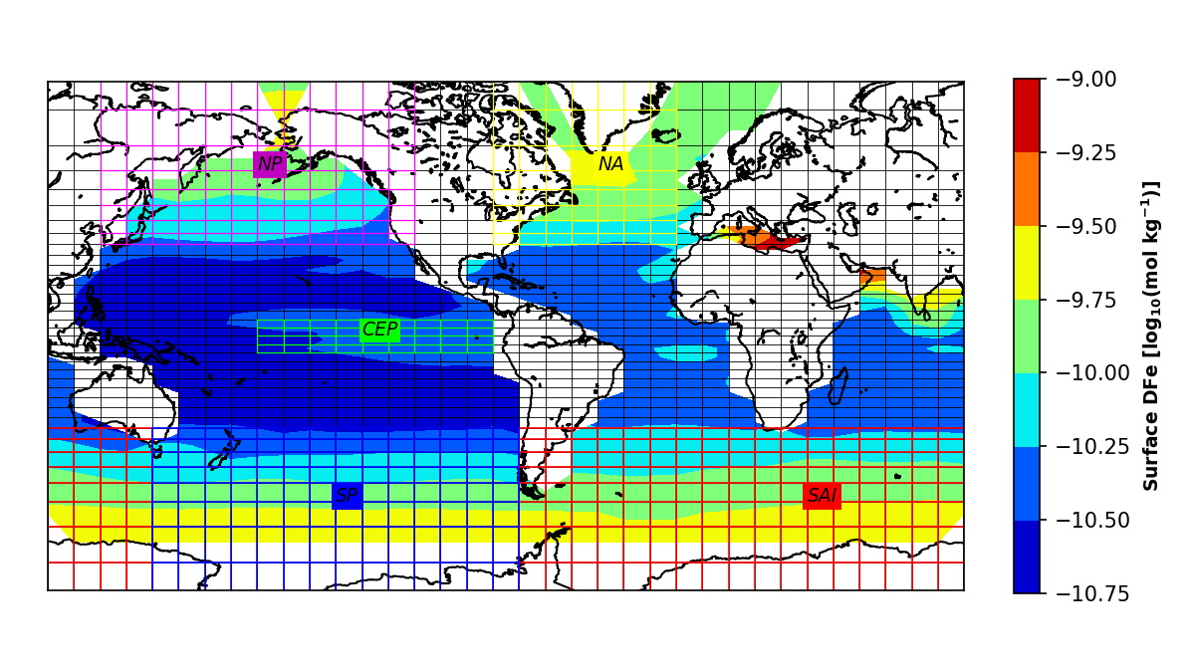

}

**Figure 1.** Dissolved iron (DFe) concentration in surface oceans based on a cGENIE biogeochemical simulation forced by a mean Holocene dust deposition flux field derived from observations (Lambert et al., 2015). The model grid is divided into 36 x 36 equal-area cells with a constant 10º-longitude resolution. Grid cells corresponding to different high-nutrient, low-chlorophyll oceans defined in the model are marked in colors (i.e., NA: North Atlantic in yellow, NP: North Pacific in purple, CEP: Central Eastern Pacific in green, SP: South Pacific in blue, SAI: South Atlantic and Indian ocean in red).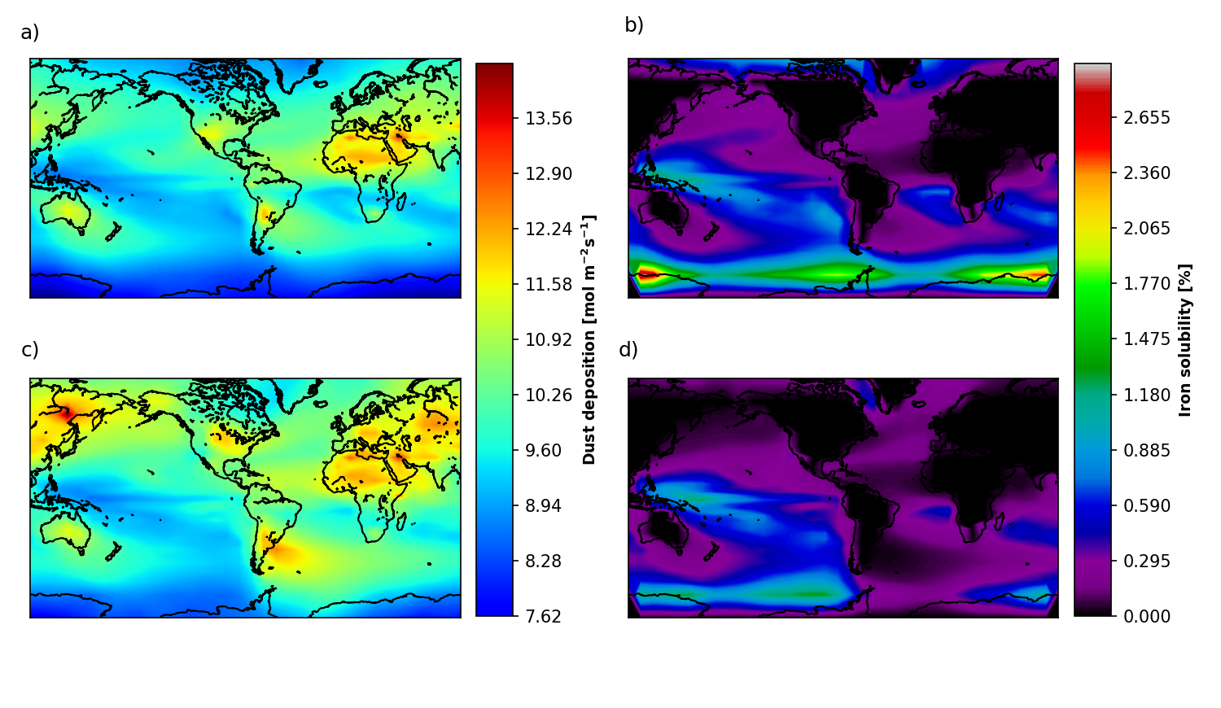

**Figure 2.** Dust deposition fluxes from Mahowald et al. (2006) (left panels) and calculated total iron fluxes (right panels), for the Holocene (top panels) and Last Glacial Maximum (bottom panels).

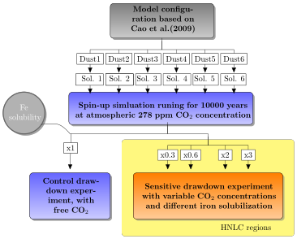

**Figure 3.** Flow chart of the experiments' implementation. The gray box shows the general configuration used for spin-up and sensitivity experiment simulations. White boxes labeled *Dust 1-6* represent the six Last Glacial Maximum (LGM) and six Holocene dust deposition flux fields used as input to the simulations, while the associated input fields of fractional iron (Fe) solubility are represented by white boxes labeled *Sol. 1-6*. The top blue box represents the spin-up simulations run for each input field of dust flux, using a fixed value for atmospheric carbon dioxide (CO2) concentration. The bottom blue box represents the control simulations run with unprescribed CO2 for each input dust field (six for LGM and six for the Holocene). The bottom yellow box represents the main set of sensitivity experiment simulations, in which for all 12 input fields of fractional iron solubility, all grids of a given high-nutrient, low-chlorophyll (HNLC) ocean basin are multiplied by the same scalar factor (0.3, 0.6, 2.0 and 3.0). The experiments were run for 10,000 years.

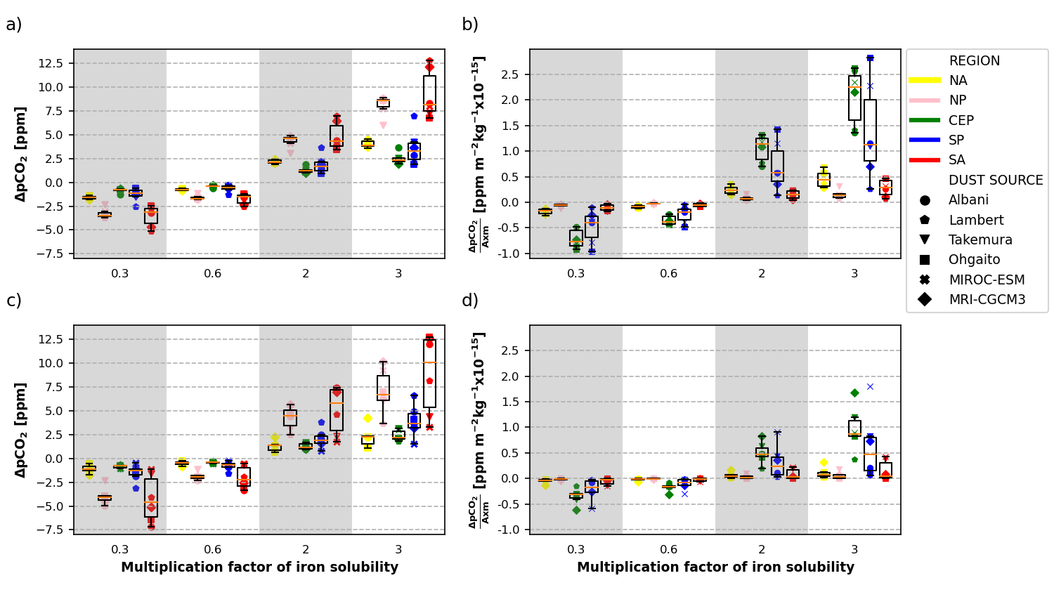

**Figure 4.** Difference in atmospheric carbon dioxide (CO2) concentration for each experiment where iron solubility is multiplied by a factor between 0.3 and 3, compared to the same experiment with no factor applied (factor = 1, left panels). Experiments using each of the dust deposition fields for Holocene (top panels) and Last Glacial Maximum (bottom panels) are discriminated with different symbols. For each simulation (single data point), the factor of iron solubility was only applied to all grid cells within a specific high-nutrient, low-chlorophyll (HNLC) ocean basin (color-coded), while iron solubility in all other grid cells in the model was left unchanged. Results were also normalized by the area (A) and the total mass of dust (m) deposited on each HNLC region (right panels).

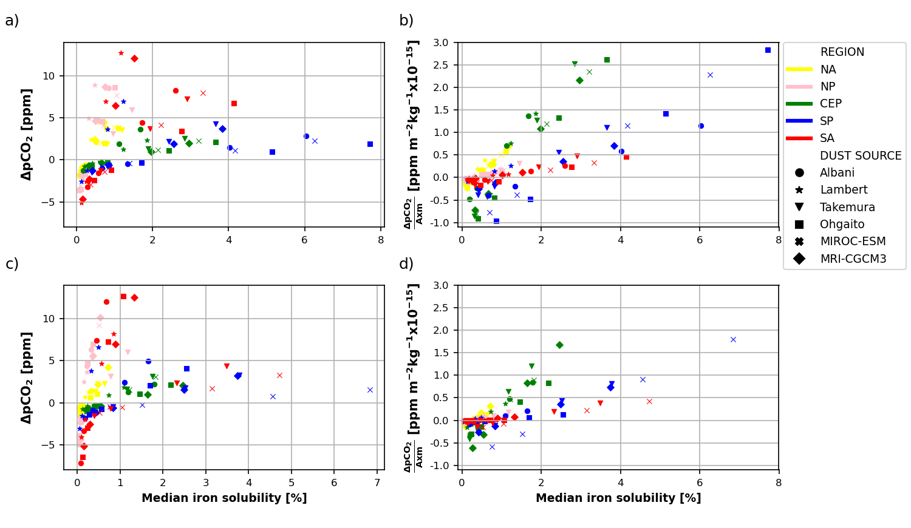

**Figure 5.** Difference in atmospheric carbon dioxide partial pressure (pCO2) with respect to median fractional iron solubility of the ocean basin considered. Regional sensitive experiments with regard to control simulations (left panels), and normalized by area and dust deposition load (right panels), for Holocene (top panels) and Last Glacial Maximum (bottom panels) dust deposition fields.

**Figure 6.** Difference in equilibrium atmospheric partial pressure of carbon dioxide (pCO2, Holocene - Last Glacial Maximum) due to aeolian dust iron fertilization with different fractional iron solubilities.